- Create a New file jupyter notebook
Model creation Exercise 1.ipynb
- Library Files:
import pandas as pd
Code | Meaning
import | Bring / Import a library into Python
pandas | Name of the library used to work with data / database objects
as pd | Give it a short name (pd) for Pandas
sklearn | library used to support the Machine Learning
All objects /Functions in Pandas library are imported into the Model creation Exercise 1.ipynb
- Variable assigned and used to getting the all the data / Datasets from csv file
l_dataset = pd.read_csv("Model Creation Exercise Salary_Data.csv")

l_dataset | Variable name used to store the data
= | Assign or store the data
Pd | Pandas library (Alias)
read_csv() | Read a CSV file
" Model Creation Exercise Salary_Data .csv" | Name of the CSV file

Pandas(pd) library, having multiple function, here we use the read.csv functions
Model Creation Exercise Salary_Data.csv file should be placed in same folder where the file Model creation Exercise 1.ipynb is located
D:\Viswa\AI\2.1 Machine Learning Regression\Simple Linear Regression
Jupyter Notebook D: drive
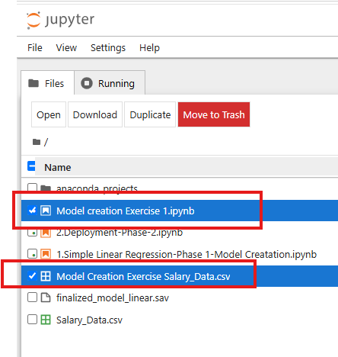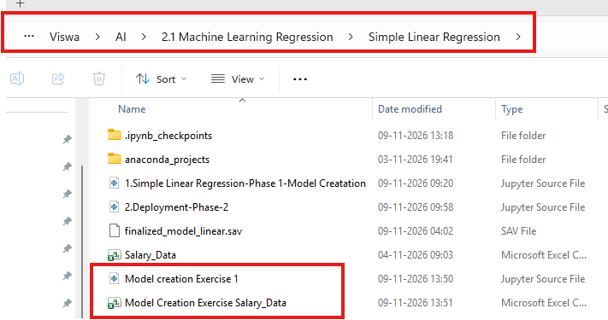
- Print the Variable by direct print or (Variable and ctrl+Enter)
print(l_dataset)
or
l_dataset
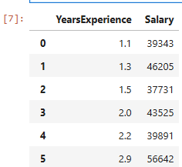
We need to split the input and output column into input/output variables
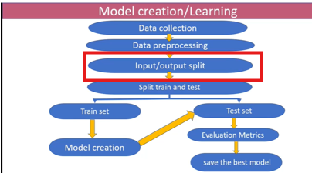
- Input Variable assigned and used to getting the single Column from csv file

independent=l_dataset[["YearsExperience"]]

Note: if we want to assign multiple column to single variable, then we use comma separator(,)
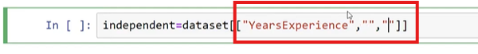
- Print the variable
print(independent)
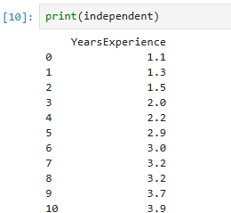
Independent
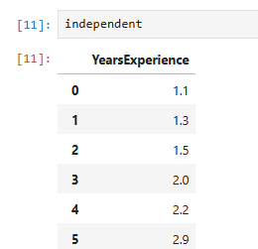
- Output Variable assigned and used to getting the single Column from csv file

Note: if we want to assign multiple column to single variable, then we use comma separator(,)

dependent = l_dataset[["Salary"]]
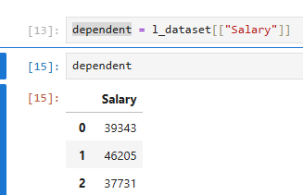
- print the output variable

print(dependent) or dependent

- Now we going to split Training Set and Test Set
Split train and test data
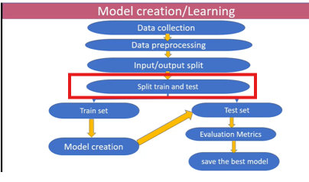
sklearn library used to support the Machine Learning
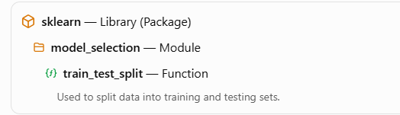

from sklearn.model_selection import train_test_split
Import the sklearn library, module of model_selection and train_test_split function into the Model creation Exercise 1.ipynb file

from sklearn.model_selection import train_test_split

Code | Meaning | Simple explanation
From | Get something from | Tells Python where to get the function from.
Sklearn | Scikit-learn library | A Python library used for Machine Learning.
model_selection | Module | A section inside Scikit-learn that contains functions for selecting and preparing models.
Import | Bring into Python file | Tells Python to bring the required function into our program.
train_test_split | Function | A function used to divide our dataset into training data and testing data.
train_test_split ( ) | Function call | Calling the Function

- train_test_split function having 4 parameters and 4 output variables for print

train_test_split (independent, dependent, test_size=0.30,random_state=0)

test_size=0.30 means , 70% training data, and 30% Test data
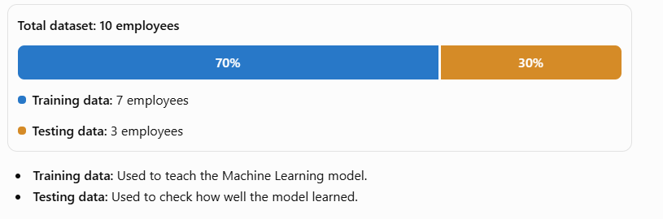
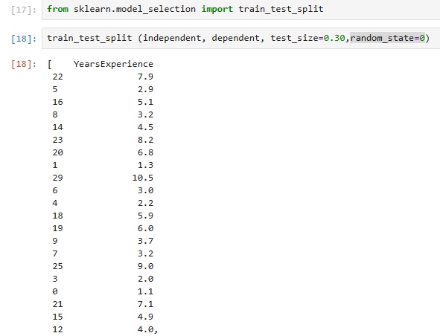
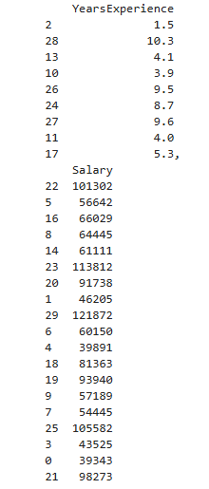
It display all the data at a time using 4 output variables
- So we Assign Output Variable (Return 4 outputs) from train_test_split() functions
X_train, X_test, y_train, y_test=train_test_split (independent, dependent, test_size=0.30,random_state=0)
X_train, X_test, y_train, y_test , these are 4 output variables for the function train_test_split()

Output variables
X_train= Trained Input
X_test= Test Input
y_train=Trained Output
y_test = Test Output

Hint:
x= input , y=output
------------------
independent=dataset[["YearsExperience"]]
X_train, X_test
dependent=dataset[["Salary"]]
y_train, y_test
test_size=0.30
random_state=0
-------------------

- Print the 4 output variables individually

X_train
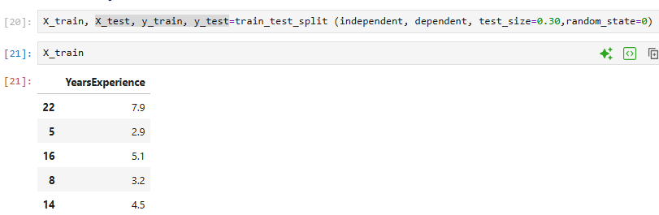

X_test

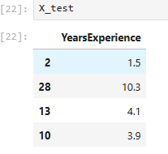

y_train
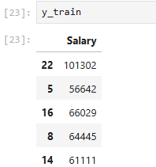
y_test
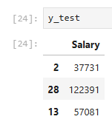

Important
Generally we assign variable to get some details .
Example
X=5
Y=6
Z=X
So here x having 5 , and Z having the value 5 from X (Input Variables).
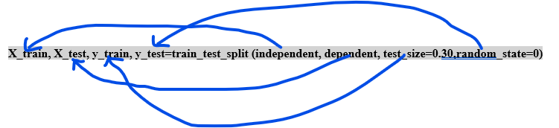
But Above screen, we don’t assign the variable to the input, we assign variables for the return output.

Generally
l_v1 = function();
It return the output of the functions

l_v2 =function(x1)
Here x1 is input, l_v2 is return the output of the function.

- Model Creation

from sklearn.linear_model import LinearRegression
regressor=LinearRegression()

- from sklearn.linear_model import LinearRegression

Code | Meaning
Sklearn | Scikit-learn library
linear_model | Module inside scikit-learn
LinearRegression | Machine Learning model (Class)

- Creating the Model
regressor=LinearRegression()

Code |  | Meaning
Regressor |  | Variable name
= |  | Assignment operator
LinearRegression() |  | Creates a Linear Regression model
Simple meaning:
We are creating an empty Linear Regression model and storing it in the variable regressor.
Think of it like a student who is ready to learn.

- Train the model
  - Keyword : Fit method

regressor.fit (X_train, y_train)

Code | Meaning
Regressor | Our created model
fit() | Function used to train the model
X_train | Input training data
y_train | Output training data

Simple meaning: To train the Model using x_train, y_train
We are teaching the model using input data (X_train) and its corresponding answers (y_train).

Employee | Learning (X) | Result (Y)
Ravi | 35 | 10
Kumar | 65 | 20
Nilla | 95 | 30

We give this information to the Linear Regression model.
- X_train → Learning values (35, 65, 95)
- y_train → Result values (10, 20, 30)

The model learns the relationship between Learning and Result.

Step | Code | Purpose
1 | from sklearn.linear_model import LinearRegression | Import the model
2 | regressor = LinearRegression() | Create the model
3 | regressor.fit(X_train, y_train) | Train the model
Remember
- LinearRegression → Model class
- regressor → Variable containing the model
- fit() → Function that trains the model
- X_train → Input data
- y_train → Correct output data
In simple words: First we import the model, then create it, and finally train it using our employee data.

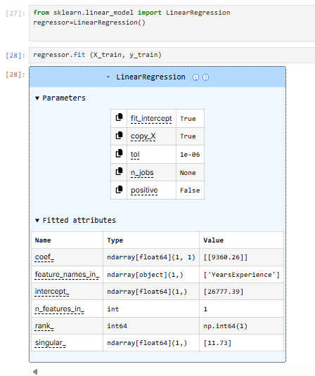

- Train the model to find the weight and Bais (Slope and Intercept)
weight=regressor.coef_
weight

bais=regressor.intercept_
bais

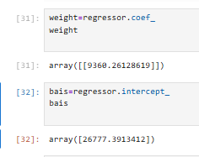

Y = mX + c
- Y = Predicted Result
- X = Learning
- m = Weight (Slope)
- c = Intercept

------taken from Machine Learning Tutorial Reference
----below is not original data sets, its for reference
Step:1 Find M (Slope)
Use the first two employees.
Calculation | Value
Difference in X | 20 - 10 = 10
Difference in Y | 65 - 35 = 30
Now:
$$m=\frac{\text{Difference in Y}}{\text{Difference in X}}$$
$$m=\frac{30}{10}=\boxed{3}$$Therefore, M = 3.
Step 2: Find C (Intercept)
Formula:
$$y=mx+c$$Use Ravi's values:
- Y = 35
- X = 10
- M = 3
Substitute:
$$35=3\left(10\right)+c$$
$$35=30+c$$
$$\boxed{c=5}$$
Therefore, C = 5.
So Based on these calculation , we calculate the x_train and y_train data
So we get the C and m Values from Salary_Data.csv
Code | Meaning
Weight | Variable name
= | Assignment operator
Regressor | Trained Linear Regression model
coef_ | Attribute that gives the model's coefficient (slope)

Simple meaning:
We are getting the coefficient (slope) learned by the Linear Regression model and storing it in the variable weight.
Important
regressor.coef_ → Gets the weight (slope). M
regressor.intercept_ → Gets the intercept. C

So Model is created
m= 9360.26128619 ,c= 26777.3913412 ,
y=mX+C

y=(9360)X+26777 . So Trained Model is created.

- Test the model
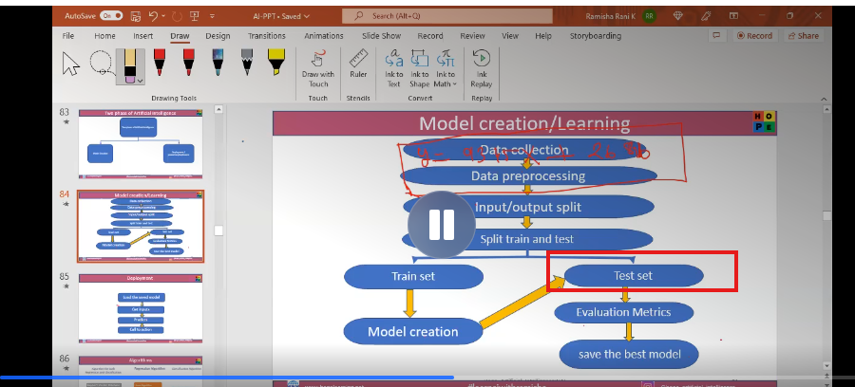
When the time of creating new model
Step | Code | Purpose
1 | from sklearn.linear_model import LinearRegression | Import the model
2 | regressor = LinearRegression() | Create the model
3 | regressor.fit(X_train, y_train) | Train the model

regressor: (New model stored in regressor)
- New model is created.
- So we need to test the model

Rule : War between Actual Input and Predicted output
- y_pred=regressor.predict(X_test)
  - Here.,
    - predict is a function,
    - X_test is a Input variable
    - y_pred is a Output variable
Predicted Output is
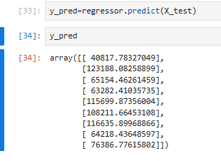
- Evaluation Method
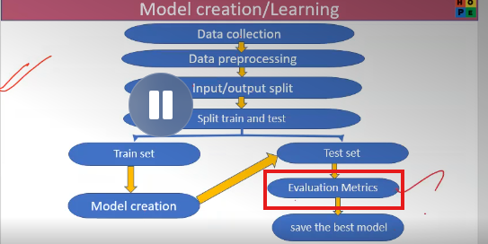
Its nothing but Rsquare (R²)
from sklearn.metrics import r2_score
Understand the complete structure
Code | Meaning
Sklearn | Scikit-learn library
Metrics | Module inside Scikit-learn
r2_score | Function inside the metrics module
from sklearn.metrics import r2_score
l_score=r2_score (y_test, y_pred)
print(l_score)
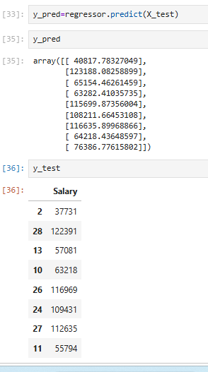
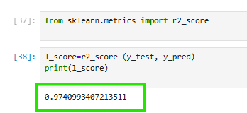
How to understand R² Score?
R² Score | Meaning
1.0 | Perfect prediction
0.9 | Very good fit
0.5 | Moderate fit
0.0 | No improvement over predicting the mean
Negative value | Worse than predicting the mean

Important to Remember:
- LinearRegression() → Creates the ML model.
- fit() → Trains the model.
- predict() → Predicts the result.
- r2_score() → Evaluates how well the model performs.

- Save the Model (Finalized model creation)

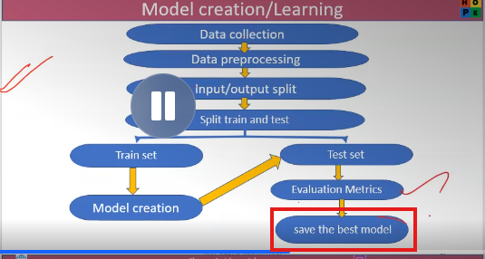
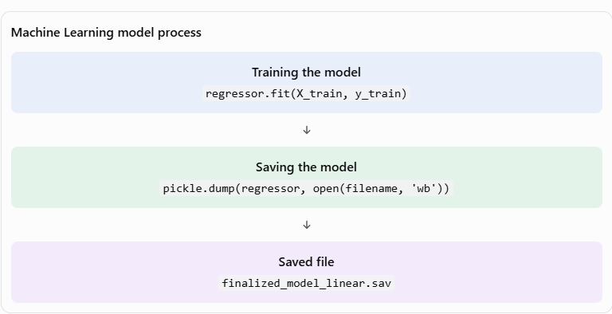
import pickle
filename="Final_Model_Creation_Exercise.sav"

1)Library
import pickle
pickle → Python library.
Used to save and load Python objects.

2)Create a filename
filename="Final_Model_Creation_Exercise.sav"

filename → Variable name.
" Final_Model_Creation_Exercise.sav" → Name of the file.
.sav → File extension.

3)Save the trained model

pickle.dump (regressor,open (filename,'wb') )

Code | Meaning
pickle.dump() | Saves the Python object
regressor | Our trained Linear Regression model
open() | Opens a file
filename | File name to save
'wb' | Write Binary mode

What does 'wb' mean?
- w → Write (save)
- b → Binary (save in binary format)

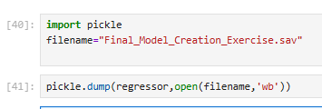

Finalized Model is created in Folder
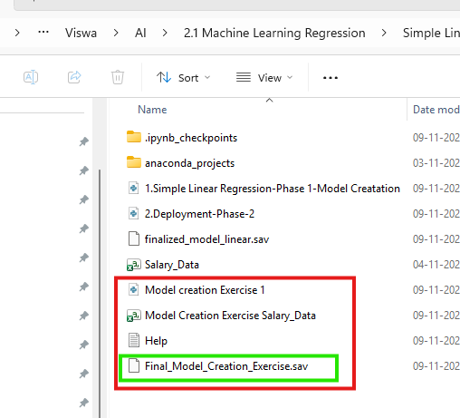

- Load the saved model

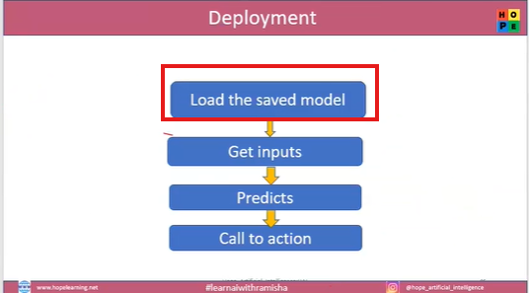
loaded_model=pickle.load(open("Final_Model_Creation_Exercise.sav",'rb'))
result=loaded_model.predict([[13]])

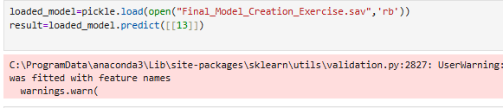

This code is used to load your previously saved Machine Learning model and predict a new value.
- Load the saved model
loaded_model=pickle.load(open("finalized_model_linear.sav",'rb'))
Code | Meaning
pickle.load() | Loads a saved Python object
open() | Opens a file
" Final_Model_Creation_Exercise.sav" | Previously saved model file
'rb' | Read Binary mode
loaded_model | Variable that stores the loaded model

What does 'rb' mean?
- r → Read (load)
- b → Binary format

- Predict a new value
result = loaded_model.predict([[13]])
Code | Meaning
Result | Variable to store the prediction
loaded_model | Our loaded Linear Regression model
predict() | Function used to predict a value
[[13]] | New input value (X = 13)

User Input value : Years of Experience given by user:13
- Print the Predicted value
result
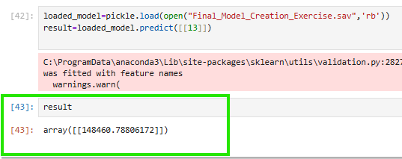

- Deploy the Saved Model
  - Create a New jupyter notebook
  - Save it as Deploy the Model creation Exercise 1. Ipynb
  - File should be same folder where the Saved Model file is located
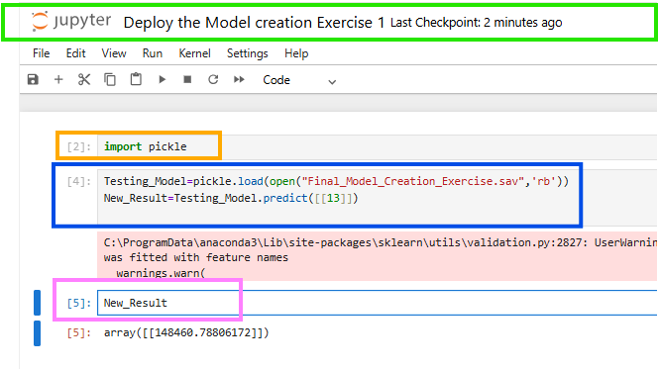

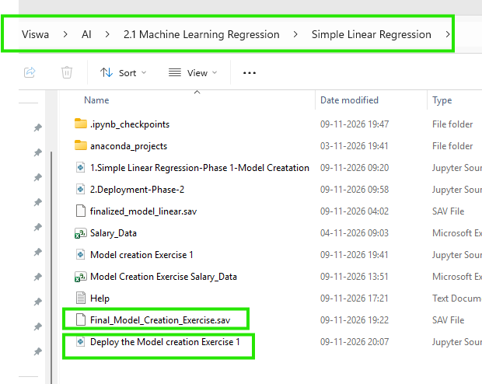
Import pickle
- Import all the functions from pickle into the Deploy the Model creation Exercise 1 Ipynb file
Testing_Model=pickle.load(open("Final_Model_Creation_Exercise.sav",'rb'))
- Testing_Model :Variable stores the Loaded model
New_Result=Testing_Model.predict([[13]])
- New_Result: Variable to store the Predicted Value
New_Result
- Print the New_Result

array([[148460.78806172]])

Exercise : Fresher joined in company. So how much salary for Fresher
Trained Model : y=(9360)X+26777 .
Fresher=Testing_Model.predict([[0]])
Fresher
Answer: array([[26777.3913412]])
Y=26777

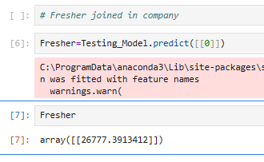
Additional information
y=(9360)X+26777
y=26777 means x value is ‘0’
y=9360(0)+26777
Note: 26777 it’s a bias value / Origin / Intercept value . C= 26777

